**Automated Testing Results**

**1.Test Valid Login**

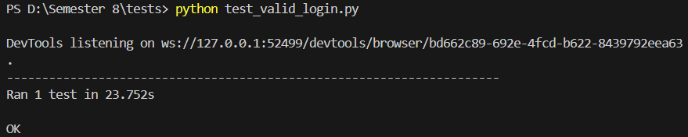

**2.Test Invalid Username**

**3. Test Invalid Password  
**

**4. Test Empty Username  
**

**5. Test Case Sensitive Username  
**

**6. Test Empty Password**

**7. Test Whitespace In Password**

**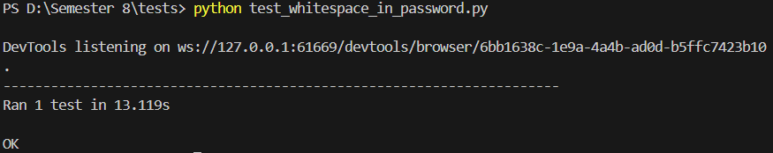  
8. Test Both Fields Empty**

**9. Test Whitespace In Username**

**10. Test Case Sensitive Password**

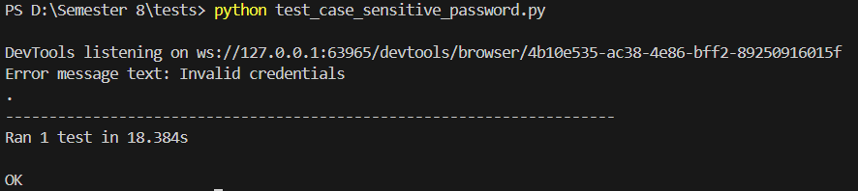

**11. Test SQL Injection Username  
**

**12. Test SQL Injection Password**

**13. Test Browser Back Button After Login**

**14. Test Password Masking**

**15. Test Forgot Password  
**